Prescription Info

(RX Card, not Medical)

NAME:

Bin:

PCN:

Group:

ID:

And For 65 years or older

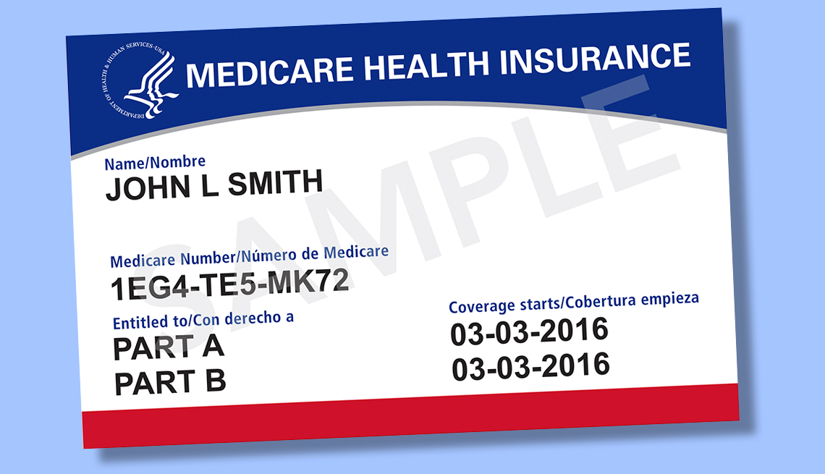Medicare B Card ID: